Plane Sections

Definition
# Source: AI Source: Provided by: [Data Path: Persons Table -> ID Column: 1, Name_En Column: Motasem Essam] -> From: [ChatGPT] on [7/25/2026]
A Plane Section is the geometric figure or region obtained when a plane intersects a three-dimensional solid or its surface.
The plane acts as an imaginary cutting surface. The resulting section reveals the shape and structure of the solid at the location and orientation of the cut.
A plane section can be:
- A two-dimensional region, when a plane intersects the interior of a solid.
- A boundary curve, when considering the intersection between the plane and the solid's surface.
- A degenerate intersection, such as a point or line, when the plane is tangent to the solid or touches it along a boundary.
In solid geometry, plane section and cross-section are often used interchangeably. More precisely, a plane section can refer to the intersection curve on a surface, while a cross-section usually refers to the complete two-dimensional region.

Geometric Representation
# Source: AI Source: Provided by: [Data Path: Persons Table -> ID Column: 1, Name_En Column: Motasem Essam] -> From: [ChatGPT] on [7/25/2026]
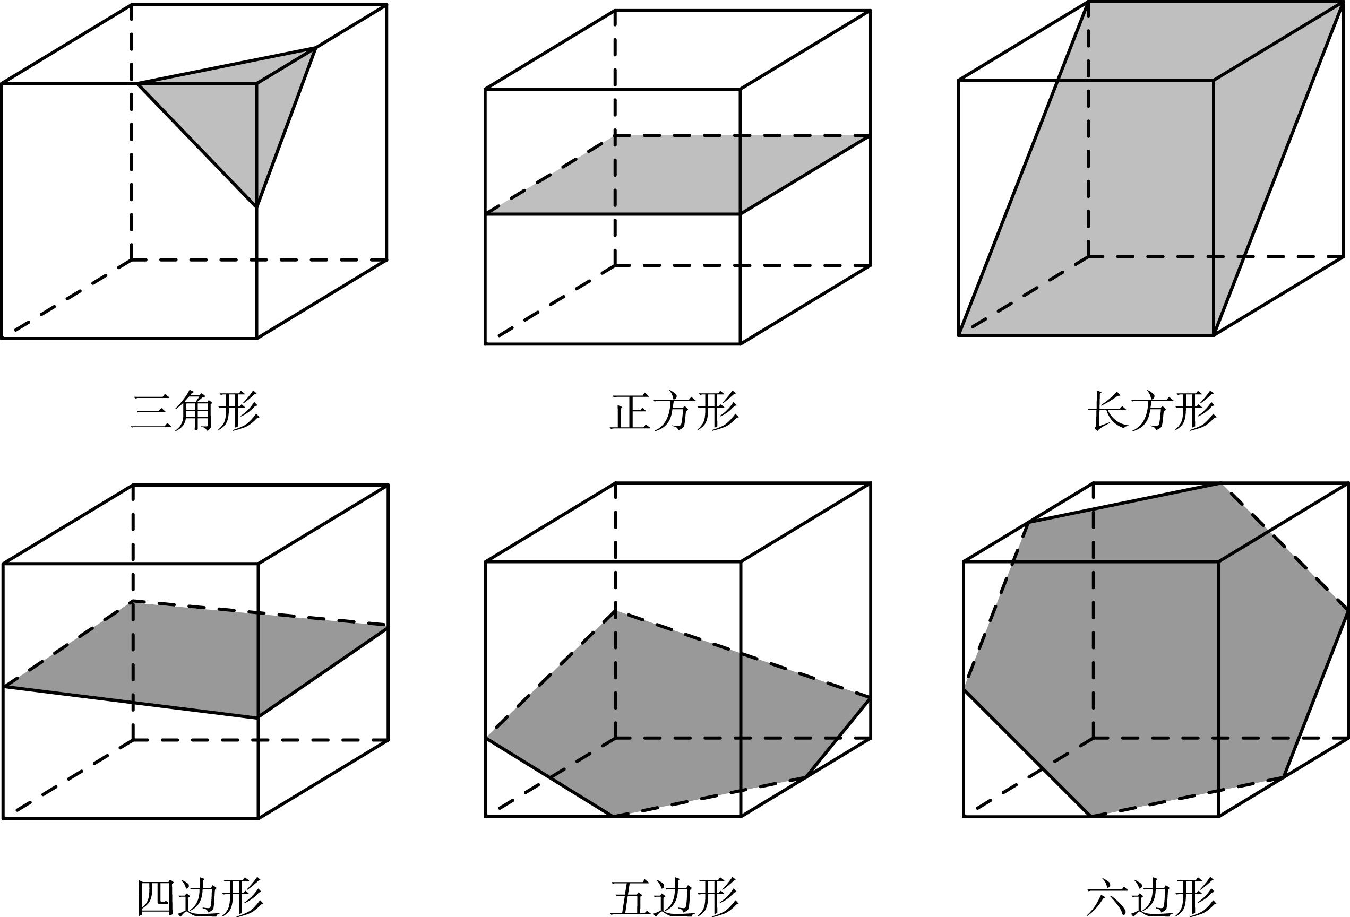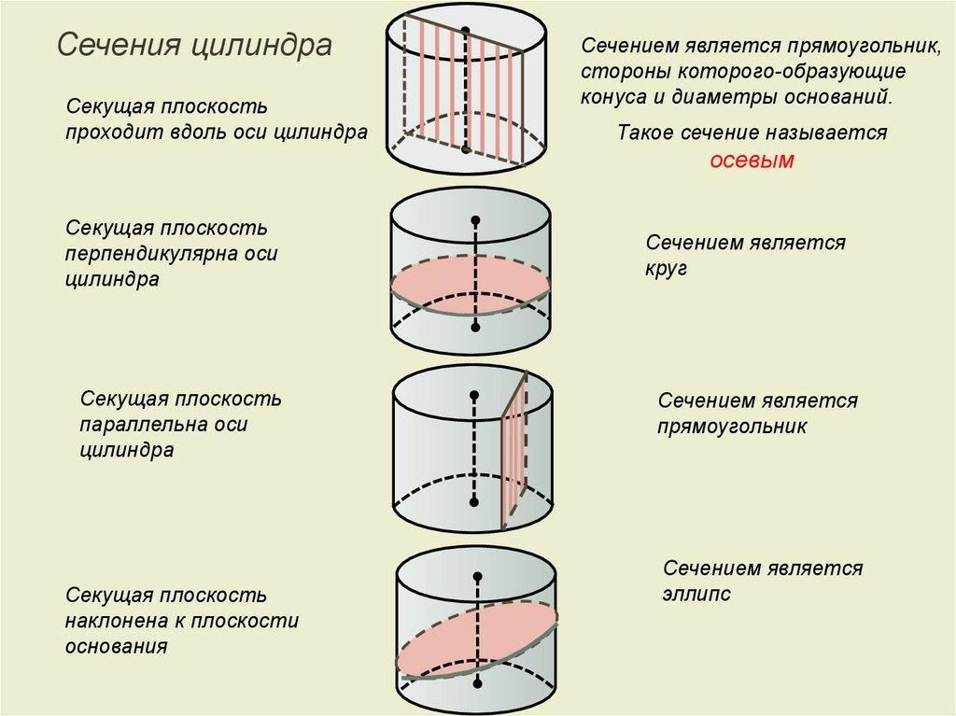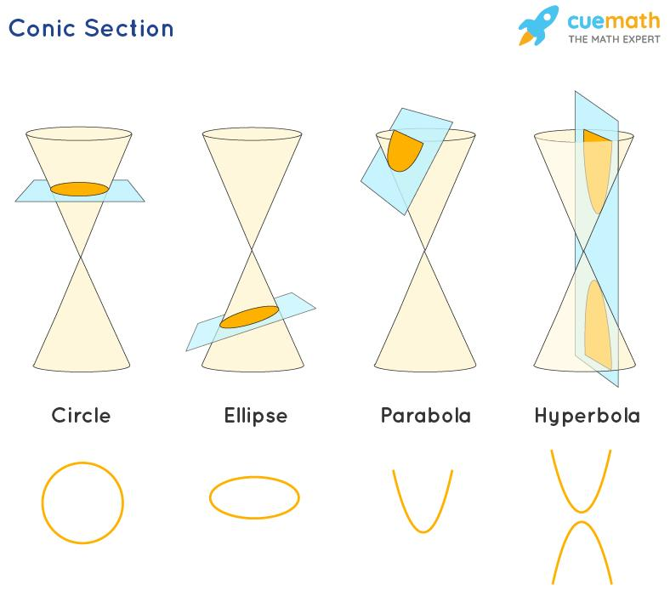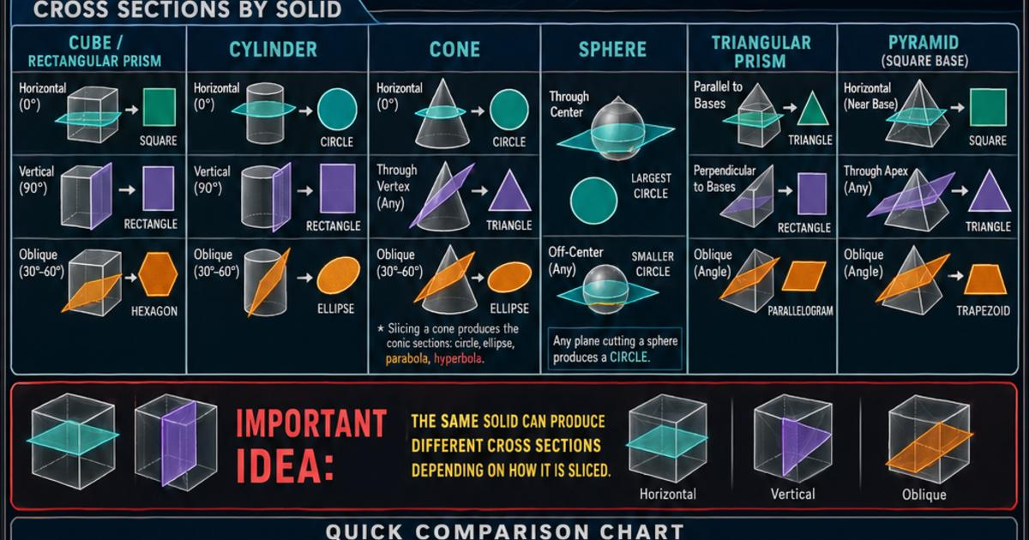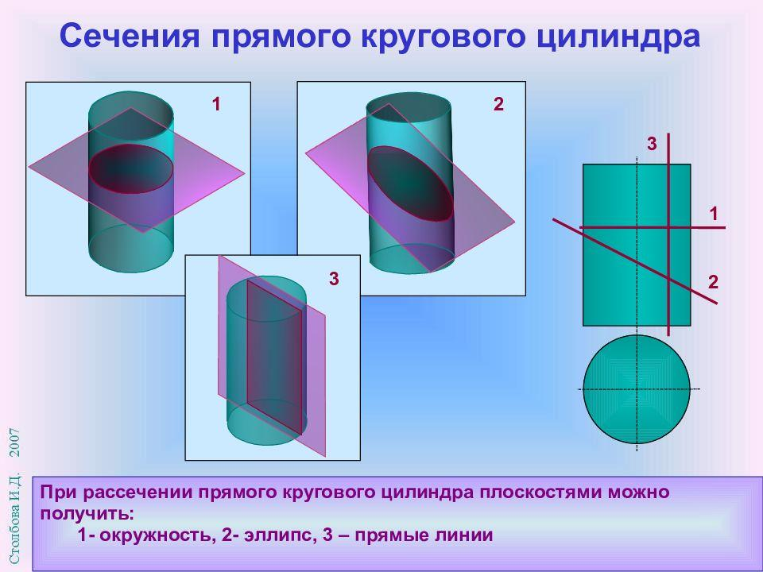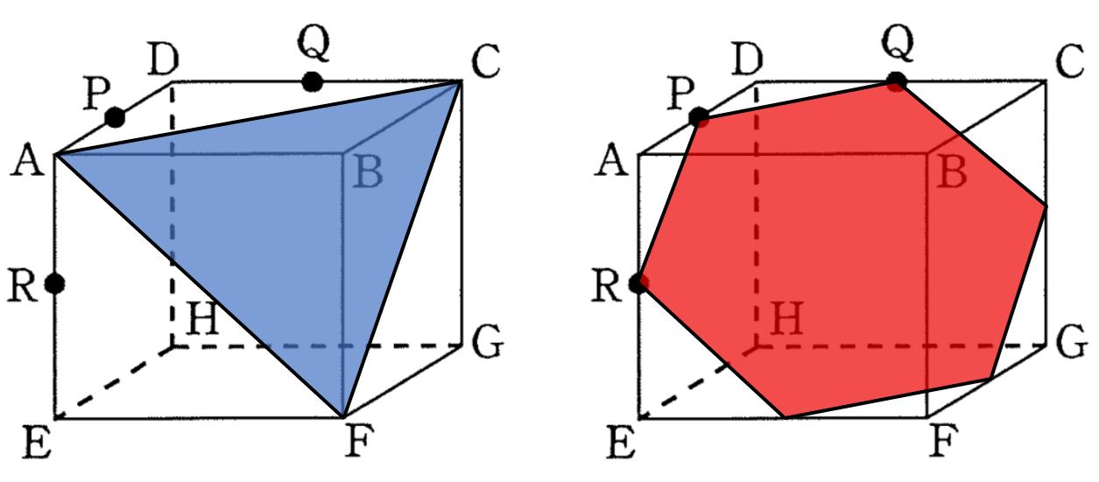
A plane section is determined by the intersection of two geometric objects:
- Solid: The three-dimensional object being intersected.
- Cutting Plane: The infinite flat plane passing through the solid.
- Plane Section: The resulting intersection.
- Section Boundary: The curve or polygonal boundary of the section.
- Section Area: The area enclosed by the section, when it is a two-dimensional region.

Geometric Structure
# Source: AI Source: Provided by: [Data Path: Persons Table -> ID Column: 1, Name_En Column: Motasem Essam] -> From: [ChatGPT] on [7/25/2026]
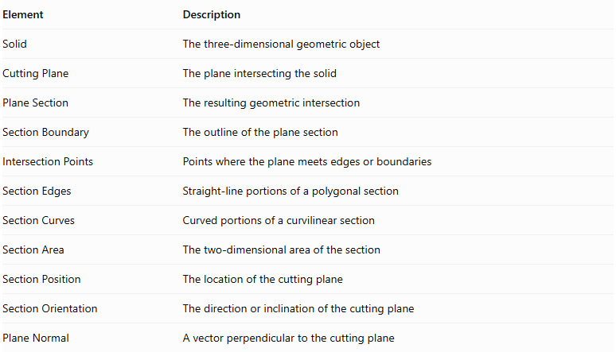
Element | Description
Solid | The three-dimensional geometric object
Cutting Plane | The plane intersecting the solid
Plane Section | The resulting geometric intersection
Section Boundary | The outline of the plane section
Intersection Points | Points where the plane meets edges or boundaries
Section Edges | Straight-line portions of a polygonal section
Section Curves | Curved portions of a curvilinear section
Section Area | The two-dimensional area of the section
Section Position | The location of the cutting plane
Section Orientation | The direction or inclination of the cutting plane
Plane Normal | A vector perpendicular to the cutting plane

Main Characteristics
# Source: AI Source: Provided by: [Data Path: Persons Table -> ID Column: 1, Name_En Column: Motasem Essam] -> From: [ChatGPT] on [7/25/2026]
- A plane section is produced by intersecting a three-dimensional solid with a plane.
- Its shape depends on the type of solid.
- Its shape also depends on the orientation and position of the cutting plane.
- The same solid can produce several different plane sections.
- A plane section may be polygonal, circular, elliptical, annular, or irregularly curvilinear.
- A section through a solid's interior normally has a two-dimensional area.
- A tangent plane may produce a point, line, or other lower-dimensional contact instead of a two-dimensional region.
- The section can be used to study the internal geometry and dimensions of a solid.

Types of Plane Sections
# Source: AI Source: Provided by: [Data Path: Persons Table -> ID Column: 1, Name_En Column: Motasem Essam] -> From: [ChatGPT] on [7/25/2026]
Plane sections can be classified according to several independent properties.

According to Plane Orientation
# Source: AI Source: Provided by: [Data Path: Persons Table -> ID Column: 1, Name_En Column: Motasem Essam] -> From: [ChatGPT] on [7/25/2026]
- Horizontal Plane Section
- Vertical Plane Section
- Oblique Plane Section
- Tangential Plane Section

According to Geometric Shape
# Source: AI Source: Provided by: [Data Path: Persons Table -> ID Column: 1, Name_En Column: Motasem Essam] -> From: [ChatGPT] on [7/25/2026]
- Polygonal Plane Section
- Circular Plane Section
- Elliptical Plane Section
- Annular Plane Section
- Irregular Curvilinear Plane Section

According to Position Relative to the Solid
# Source: AI Source: Provided by: [Data Path: Persons Table -> ID Column: 1, Name_En Column: Motasem Essam] -> From: [ChatGPT] on [7/25/2026]
- Central Plane Section
- Off-Center Plane Section
- Axial Plane Section
- Non-Axial Plane Section
- Boundary Plane Section
These are descriptive classifications. Some may overlap: for example, an axial plane section can also be vertical or oblique.

According to the Number of Connected Components
# Source: AI Source: Provided by: [Data Path: Persons Table -> ID Column: 1, Name_En Column: Motasem Essam] -> From: [ChatGPT] on [7/25/2026]
- Single-Component Plane Section
- Multi-Component Plane Section

Plane Sections According to Solid Type
# Source: AI Source: Provided by: [Data Path: Persons Table -> ID Column: 1, Name_En Column: Motasem Essam] -> From: [ChatGPT] on [7/25/2026]

Polyhedra
# Source: AI Source: Provided by: [Data Path: Persons Table -> ID Column: 1, Name_En Column: Motasem Essam] -> From: [ChatGPT] on [7/25/2026]
Sections are generally polygons because their boundaries are formed by intersections with flat faces.
Examples:
- Cube: triangular, quadrilateral, pentagonal, or hexagonal sections.
- Prism: polygonal sections.
- Pyramid: triangular or other polygonal sections.
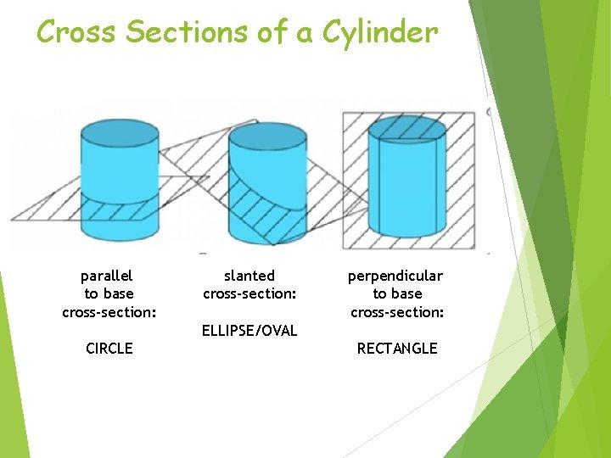

Cylinders
# Source: AI Source: Provided by: [Data Path: Persons Table -> ID Column: 1, Name_En Column: Motasem Essam] -> From: [ChatGPT] on [7/25/2026]
Possible sections include:
- Circle: plane perpendicular to the axis of a right circular cylinder.
- Rectangle: plane parallel to its axis.
- Ellipse: suitable inclined plane, away from the end bases.
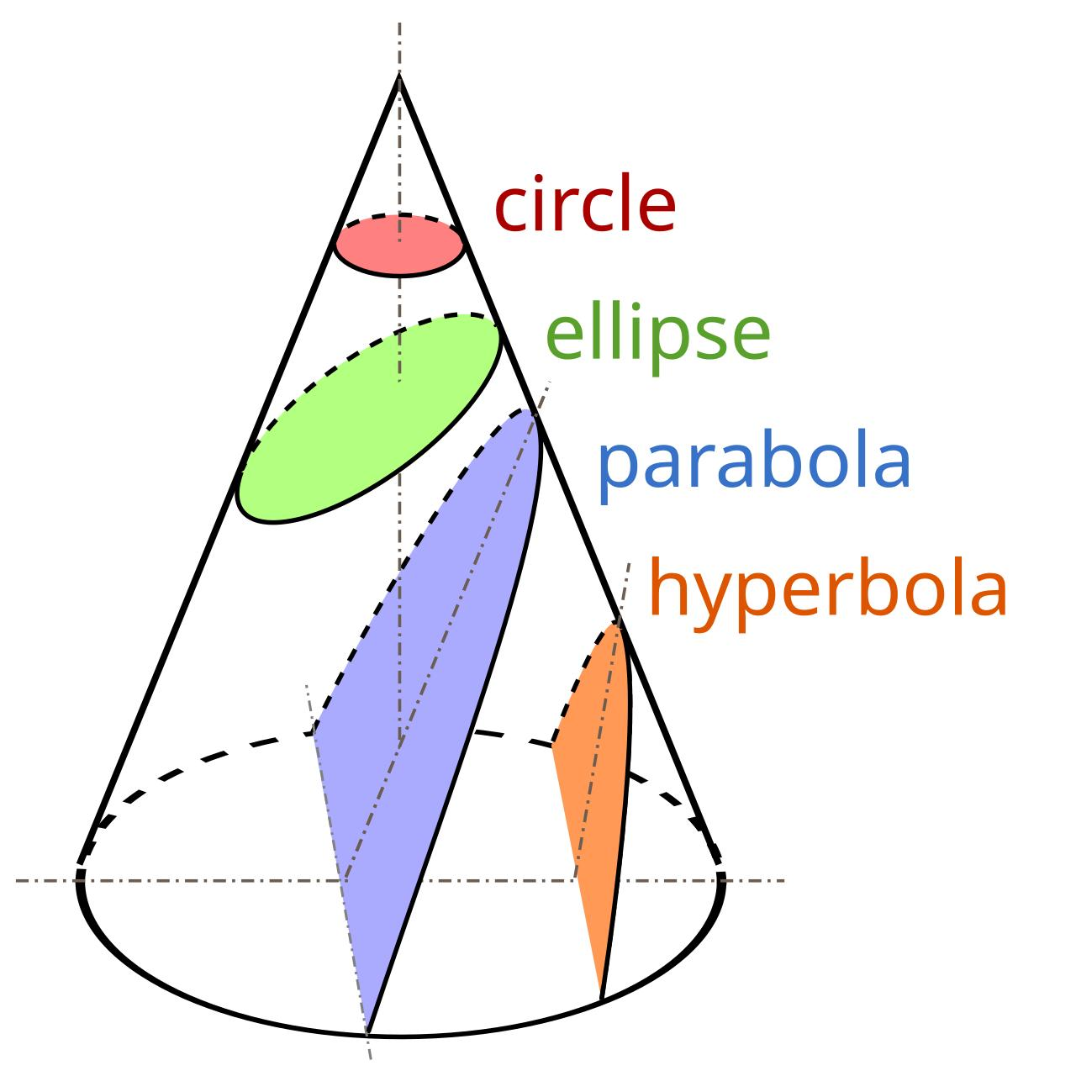

Cones
# Source: AI Source: Provided by: [Data Path: Persons Table -> ID Column: 1, Name_En Column: Motasem Essam] -> From: [ChatGPT] on [7/25/2026]
Depending on the cutting plane, conic sections include:
- Circle
- Ellipse
- Parabola
- Hyperbola
These classifications apply to suitable sections of a double cone; a finite cone may produce sections clipped by its base.
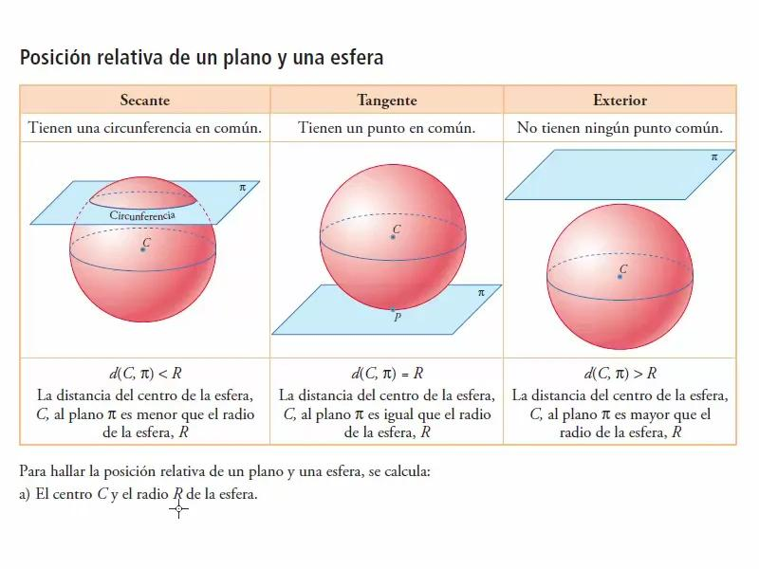

Spheres
# Source: AI Source: Provided by: [Data Path: Persons Table -> ID Column: 1, Name_En Column: Motasem Essam] -> From: [ChatGPT] on [7/25/2026]
- Central plane: great circle.
- Off-center plane: smaller circle.
- Tangent plane: single point.
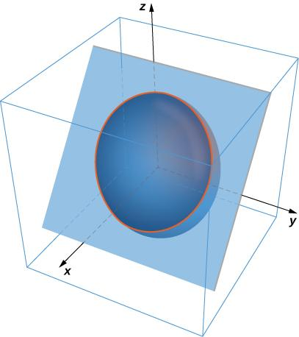

Ellipsoids
# Source: AI Source: Provided by: [Data Path: Persons Table -> ID Column: 1, Name_En Column: Motasem Essam] -> From: [ChatGPT] on [7/25/2026]
Plane sections through the interior are generally ellipses. Their dimensions depend on the position and orientation of the plane.
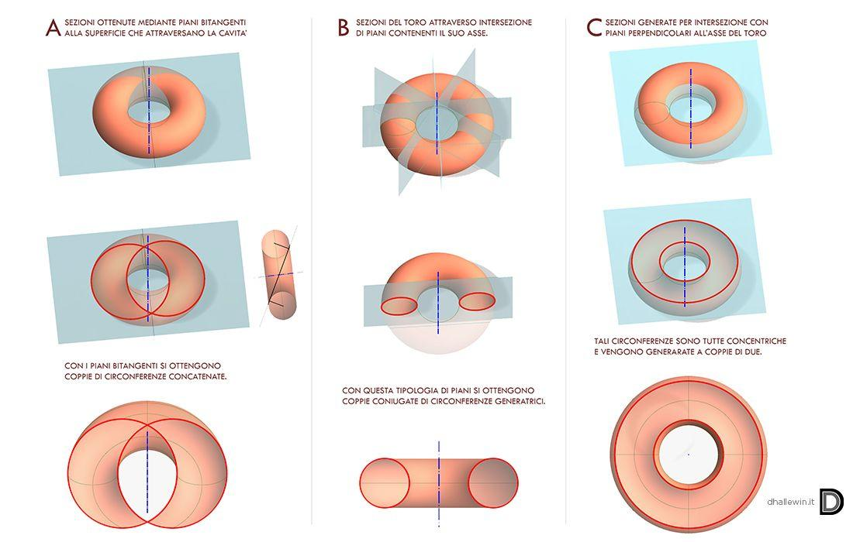

Tori
# Source: AI Source: Provided by: [Data Path: Persons Table -> ID Column: 1, Name_En Column: Motasem Essam] -> From: [ChatGPT] on [7/25/2026]
- Horizontal central section of a ring torus: annulus.
- Vertical central section: two circular regions.
- Other inclined sections: potentially irregular curvilinear regions.

Mathematical Representation

General Plane Equation
# Source: AI Source: Provided by: [Data Path: Persons Table -> ID Column: 1, Name_En Column: Motasem Essam] -> From: [ChatGPT] on [7/25/2026]
A plane in three-dimensional Cartesian coordinates is represented by:
$$ax+by+cz+d=0$$
Where:
- $a,b,c$: coefficients defining the plane's normal direction.
- $d$: constant determining its position.
- $(x,y,z)$: coordinates of points on the plane.
The normal vector is:
$$vecn=(a,b,c)$$

Plane Section as an Intersection
# Source: AI Source: Provided by: [Data Path: Persons Table -> ID Column: 1, Name_En Column: Motasem Essam] -> From: [ChatGPT] on [7/25/2026]
Let $S$ represent a solid and $P$ represent a plane.
The plane section is:
$$C=S∩P$$
Where:
- $C$: intersection of the solid and plane.
- $S$: three-dimensional solid.
- $P$: cutting plane.
If $S$ represents only the solid's surface rather than its filled interior, the intersection describes the section boundary.

Section Area
# Source: AI Source: Provided by: [Data Path: Persons Table -> ID Column: 1, Name_En Column: Motasem Essam] -> From: [ChatGPT] on [7/25/2026]
The area of a plane section is:
$$A={iint}_{C}dA$$
For common section shapes:
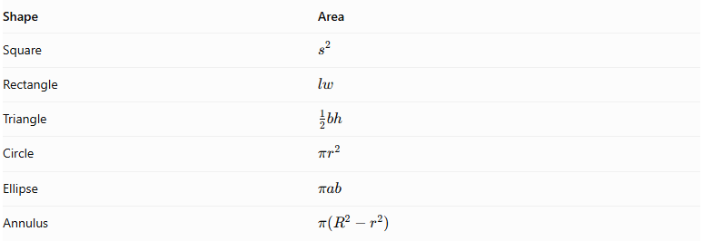
Shape | Area
Square | $$s^{2}$$
Rectangle | $$lw$$
Triangle | $$\frac{1}{2}bh$$
Circle | $$πr^{2}$$
Ellipse | $$πab$$
Annulus | $$π(R^{2}-r^{2})$$

Volume Using Plane Sections
# Source: AI Source: Provided by: [Data Path: Persons Table -> ID Column: 1, Name_En Column: Motasem Essam] -> From: [ChatGPT] on [7/25/2026]
The volume of a solid can be calculated by integrating the areas of its parallel plane sections:
$$V=\int_{a}^{b}{A(t)} dt$$
Where:
- $V$: volume of the solid.
- $A(t)$: area of the section at position $t$.
- $a,b$: limits along the direction perpendicular to the parallel cutting planes.

Plane Sections and Related Geometric Concepts
# Source: AI Source: Provided by: [Data Path: Persons Table -> ID Column: 1, Name_En Column: Motasem Essam] -> From: [ChatGPT] on [7/25/2026]
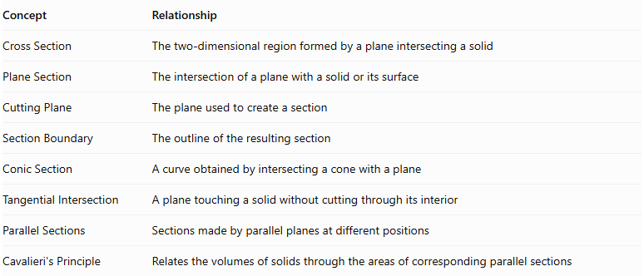
Concept | Relationship
Cross Section | The two-dimensional region formed by a plane intersecting a solid
Plane Section | The intersection of a plane with a solid or its surface
Cutting Plane | The plane used to create a section
Section Boundary | The outline of the resulting section
Conic Section | A curve obtained by intersecting a cone with a plane
Tangential Intersection | A plane touching a solid without cutting through its interior
Parallel Sections | Sections made by parallel planes at different positions
Cavalieri's Principle | Relates the volumes of solids through the areas of corresponding parallel sections
Important distinction: A plane section is not a projection or a shadow. A section consists only of points that actually belong to both the solid and the cutting plane.

Applications
# Source: AI Source: Provided by: [Data Path: Persons Table -> ID Column: 1, Name_En Column: Motasem Essam] -> From: [ChatGPT] on [7/25/2026]
- Engineering: Examining the internal structure of mechanical components.
- Architecture: Understanding the shapes and internal arrangements of buildings.
- Manufacturing: Determining the geometry of cut materials and components.
- Medical Imaging: Understanding internal structures through sectional images.
- Mathematics: Studying the relationship between three-dimensional solids and two-dimensional figures.
- Volume Calculations: Using sectional areas to calculate solid volumes.
- Geology: Studying underground structures through sectional representations.

Main Classification
# Source: AI Source: Provided by: [Data Path: Persons Table -> ID Column: 1, Name_En Column: Motasem Essam] -> From: [ChatGPT] on [7/25/2026]
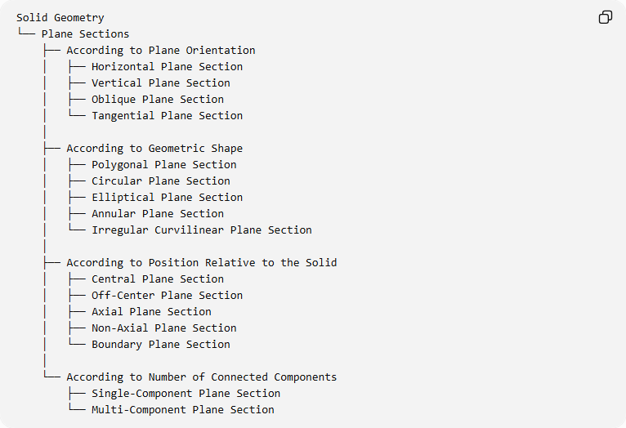
Solid Geometry
└── Plane Sections
├── According to Plane Orientation
│ ├── Horizontal Plane Section
│ ├── Vertical Plane Section
│ ├── Oblique Plane Section
│ └── Tangential Plane Section
│
├── According to Geometric Shape
│ ├── Polygonal Plane Section
│ ├── Circular Plane Section
│ ├── Elliptical Plane Section
│ ├── Annular Plane Section
│ └── Irregular Curvilinear Plane Section
│
├── According to Position Relative to the Solid
│ ├── Central Plane Section
│ ├── Off-Center Plane Section
│ ├── Axial Plane Section
│ ├── Non-Axial Plane Section
│ └── Boundary Plane Section
│
└── According to Number of Connected Components
├── Single-Component Plane Section
└── Multi-Component Plane Section

Key Points
# Source: AI Source: Provided by: [Data Path: Persons Table -> ID Column: 1, Name_En Column: Motasem Essam] -> From: [ChatGPT] on [7/25/2026]
- A plane section is formed by the intersection of a plane and a three-dimensional solid.
- Its geometry depends on the solid, plane orientation, and plane position.
- Plane sections can have polygonal, circular, elliptical, annular, or irregular curvilinear shapes.
- One solid can produce different sections under different cutting conditions.
- The areas of parallel plane sections can be used to calculate volume.

Conclusion
# Source: AI Source: Provided by: [Data Path: Persons Table -> ID Column: 1, Name_En Column: Motasem Essam] -> From: [ChatGPT] on [7/25/2026]
Plane Sections are an important concept in solid geometry because they connect three-dimensional objects with two-dimensional geometric figures. By studying the orientation, position, shape, and area of plane sections, we can understand the internal structure of solids, classify their geometric intersections, and solve problems involving surface geometry and volume.

Sources
# Source: AI Source: Provided by: [Data Path: Persons Table -> ID Column: 1, Name_En Column: Motasem Essam] -> From: [ChatGPT] on [7/25/2026]
- Khan Academy – Solid Geometry Vocabulary and Cross Sections
- Math Is Fun – Cross Sections
- LibreTexts – Cross-Sections and Nets
- Minnesota State University – Cross Section Lesson

